**AddressIQ API - File Upload & Processing - Postman Testing Steps**

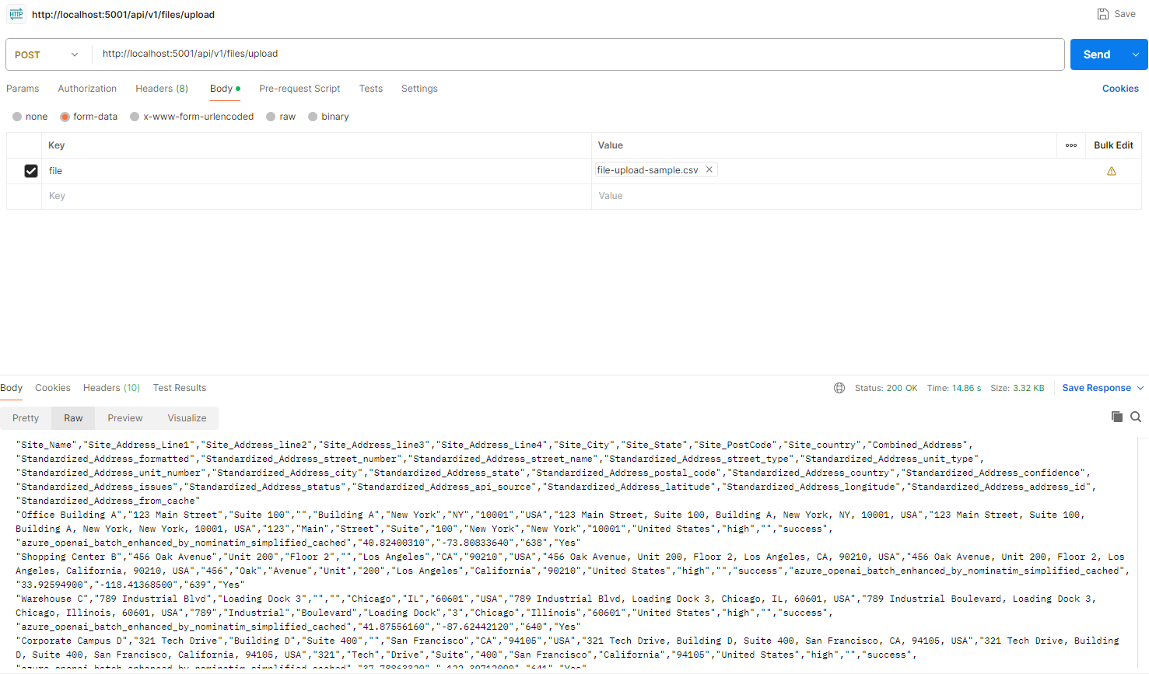  
  
(Paste your screenshot image here when you open this in Word)

**STEP 1: Open Postman**

* Launch Postman application
* Create a new request

**STEP 2: Configure Request Method**

* Set Method to: **POST**
* **← In screenshot: Method dropdown set to "POST" (USER FILLS THIS)**

**STEP 3: Enter API URL**

* Enter URL: http://localhost:5001/api/v1/files/upload
* **← In screenshot: URL bar with the API endpoint (USER FILLS THIS)**

**STEP 4: Configure Request Body**

* Click on "Body" tab
* Select "form-data" option (NOT binary, NOT raw)
* **← In screenshot: "form-data" radio button selected (USER SELECTS THIS)**

**STEP 5: Add File Parameter**

* In Key field: Enter **"file"**
* **← In screenshot: Key field with "file" (USER TYPES THIS)**
* Change Key type from "Text" to **"File"** using dropdown
* **← In screenshot: Dropdown showing "File" selected (USER SELECTS THIS)**
* In Value field: Click "Select Files" and choose your CSV/Excel file
* **← In screenshot: "file-upload-sample.csv" selected (USER SELECTS THEIR FILE)**

**STEP 6: Send Request**

* Click the blue **"Send"** button
* Wait for processing (may take 10-30 seconds)
* **← In screenshot: Status "200 OK" and Time "14.8s" (SHOWS SUCCESS)**

**STEP 7: Download Result**

* Look for **"Save Response"** button (top-right of response area)
* Click "Save Response" to download processed CSV file
* **← In screenshot: Response body with CSV data (PROCESSED FILE CONTENT)**

**SUCCESS INDICATORS:**

* Status: **200 OK** (shown in screenshot)
* Response contains CSV data with additional standardization columns
* Processing time displayed (14.8s in screenshot example)

**TROUBLESHOOTING:**

* If you get "No file provided" error → Make sure body type is "form-data" not "binary"
* If you get connection error → Make sure server is running on localhost:5001
* If processing takes too long → Wait, address standardization requires AI processing time

**That's it! Your file will be processed and returned with enhanced address data.**